Ammonium mass detection protocol and sampler

Pete Marchetto, Soil and Water Lab, Department of Biological and Environmental Engineering, Cornell University, Ithaca, NY, USA

# Introduction

There is a current dearth of inexpensive means to determine mass fraction of ammonium salts in liquid samples. The method described herein allows for inexpensive yet precise measurement of ammonium content using only simple lye in the form of KOH. This is possible given the following:

$$NH_{4}^{+}+A^{-}+H_{2}O+KOH→NH_{3}+H_{2}O+KA$$

where *A* is the anion attached to the ammonium group. *KA* is necessarily soluble in water, while *NH*3 is the only gas produced, and therefore the only mass to be lost. Thus, by calculating the amount of mass lost, the amount of ammonium content in the sample can be found. This same equation holds true for *NaOH, LiOH,* and other metals in this series.

The yield can be maximized for this reaction by increasing the amount of *KOH* in the solution, thus increasing the pH. However, ammonia is easily soluble in water. To remove the total quantity of ammonia, the temperature may be increased to around 95 °C, which will allow over 95% of the ammonia to be pushed out of solution. With the subsequent off gassing of ammonia, the mass of the solution will decrease, and so the total amount of ammonium ion in the solution can be known.

The relative concentrations of ammonia and ammonium ions relative to pH can be seen in Fig. 1. The solubility of ammonia in water as a function of temperature can be seen in Fig. 2.

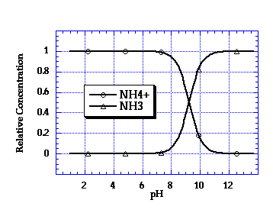

Fig. 1: Relative concentrations of NH4+ and NH3 as functions of pH. From Richard.

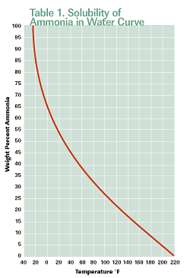

Fig. 2: Solubility of NH3 in water as a function of temperature. From Process Cooling Magazine.

# Materials and Methods

For the first lab test, two salts were used, and so two concentrations of *NH*4*SO*4 and *NH*4*Cl* were prepared. These four samples were weighed in their containers, then put on an Isotemp hot plate (Fisher Scientific, Waltham, MA, USA), set to just below 100 °C. They were allowed to heat in a fume hood for thirty minutes, then removed and weighed again. The *∆m* was recorded, and calculated relative to the initial mass for a yield percentage.

# Results

|  |  |  |  |  |  |  |
| --- | --- | --- | --- | --- | --- | --- |
| Sample | Initial Mass (g) | Final Mass (g) | ∆m (g) | Total NH4+ Mass (g) | Salt Type | Percent Yield |
| 1 | 83.307 | 82.979 | 0.328 | 0.568 | NH4SO4 | 57.74647887 |
| 2 | 83.99 | 83.742 | 0.248 | 0.301308 | NH4SO4 | 82.30780464 |
| 3 | 83.567 | 83.199 | 0.368 | 0.703 | NH4Cl | 52.34708393 |
| 4 | 83.025 | 82.776 | 0.249 | 0.41593 | NH4Cl | 59.86584281 |